PLATFORM IDENTIFICATION:

========================

we analyze security against the services that limits allowance only to the registered platforms for their users, of which core technology is called designated platform solution and it has been deployed in several critical services such as on-line banking, financial transactions and so on ...

Platform identification means to find the OS information when there are multiple OS to run on single processor then based on OS information which OS user wants to run in that OS user application will execute.

In module optee_os /lib folder is available in that lib/libutee library is present . In libutee folder tee_api_property.c file available in that tee_api_property.c a function with name TEE_GetPropertyAsString() function is defined.

Internally TEE_GetPropertyAsString() this function will call propget_get_property().

If we want OPTEE OS information like OS name , Os provider , OS version we will pass different arguments to that function from our application then TEE_GetPropertyAsString() gives related information about optee. We can also use one more function platform() from application by passing different arguments to platform() then this will return the OS related information. From application we call the macro PLAT_OPTEE then it will calls OPTEE related functions and gives OS related information.

This OS related information stored in structure we pass this structure to configuration framework.

FLOWCHAT OF PLATFORM IDENTIFICATIONS:

=====================================

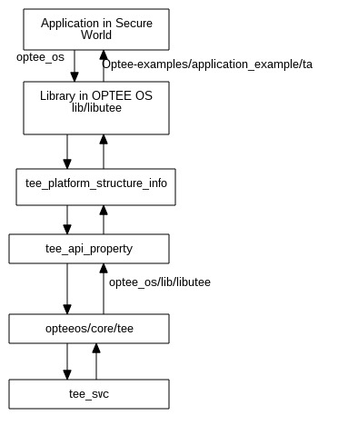

Example:

-----------

From application we call the macro PLAT_OPTEE then it will calls OPTEE related functions in optee_os/lib/libutee/tee_platform_structure_info.c function.In that tee_platform_structure_info.c file will call platform() in this functions we are passing related arguments.

This platform() function will call tee_api_property.c file a function with name propget_get_property function is called .This function internally call propset_get() ,utee_get_property_name_to_index and utee_get_property().

This utee_get_property() update the Os structure information.